GIT SETUP , WORKING & COMMANDS

Establish a new directory populate it with script files, initiate an empty repository on git hub, convert the local directory into a git repository, and link it github for pushing the code into the repository perform merge rebase stash commands in following github repository

Git is an open-source distributed version control system that helps teams track and manage code changes, collaborate seamlessly, and work on projects of any size. It keeps a history of every change, allowing you to revisit or restore previous versions, and makes it easy to fix mistakes without losing progress.

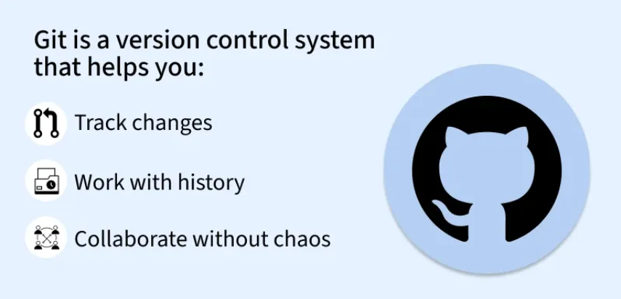

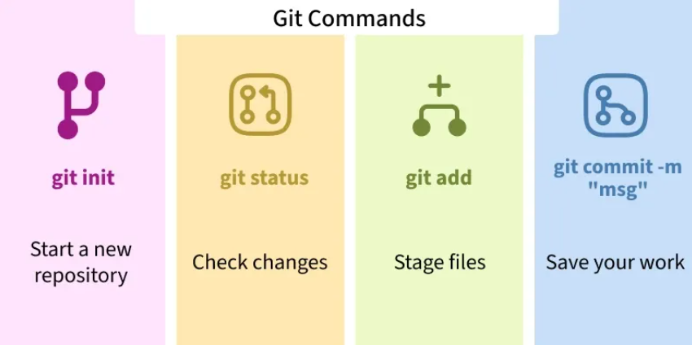

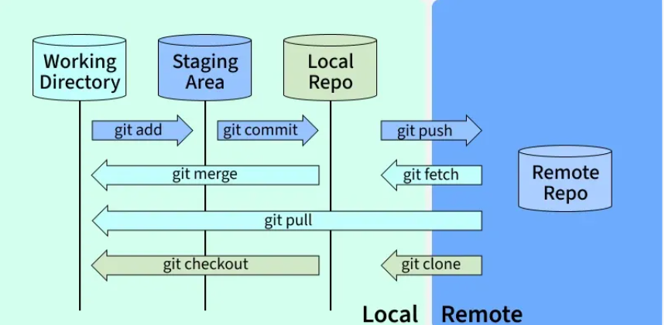

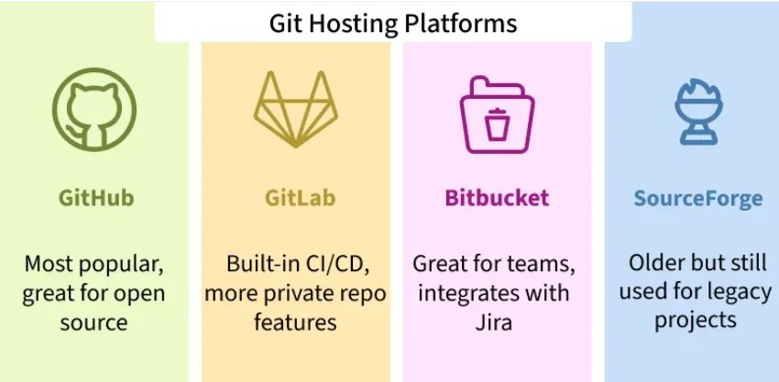

GIT REPOSITORY:

A Git repository (or repo) is a storage space where your project’s files and their complete history of changes are kept. It allows you to track, manage, and collaborate on code over time.

Types of Git Repositories

1. Local Repository

Stored on your own computer.

Allows you to make changes, commit them, and review your project history
without needing an internet connection.

Example: The .git folder inside your project contains the local repository.

- Remote Repository

Hosted on a server like GitHub, GitLab, or Bitbucket.

Enables multiple developers to collaborate on the same project.

Supports operations like push, pull, and fetch to synchronize changes with the local repository.

Initialize a Git Repository

Before you can start tracking files, you need to initialize a repository in your project folder. This is done with the git init command.

$ git init

Cloning And Synchronizing With Remote Repositories

Git lets users clone repositories to their local machine, creating separate copies. To sync changes with others, Git provides commands to synchronize local repositories with remote one.

push

pull

Git Push And Pull Commands

Git Push

This git push command is used to push all the commits of the current repository to the tracked remote repository. This command can be used to push your repository to multiple repositories at once.

Syntax

$ git push -u origin master

To push all the contents of our local repository that belong to the master branch to the server (Global repository).

Git Pull

The git pull command updates your local repository by fetching and merging changes from the remote repository. It ensures your copy stays synchronized when others have made updates.

Syntax

$ git pull

Git Status

It is used for checking the status of git repository, i.e., if the files are committed or not, files in staging area or untracked file.

Syntax

$ git status

Git Log

It is used to track all the changes made in the repository, providing the information on contributors and their contributions.

Syntax

$ git log

.gitignore

You may use .gitignore if you want to hide any file when uploading online. Just simply create a .gitignore file, and write all the files names you want to ignore.

Git Merge

It is used to merge two branches within the same repository. It combines the changes from one branch into another (usually merging a feature branch into the main branch) without losing history.

Syntax

$ git merge <branch-name>

Git Checkout

It is used to rollback to previous version of the project which was committed anytime earlier. You can copy to hash-code from git log and use it to rollback.

Syntax

$ git checkout <hash-code>

Creating .gitignore file (.gitignore)

Step 1: Open your terminal/cmd and change your directory to the folder where your files are located. You can use " ls -a" command to view its contents.

cd directory(or)folder
ls -a

Here, the project files are saved inside folder named story which is further inside web development. Here, we want git to ignore the secrets.txt file.

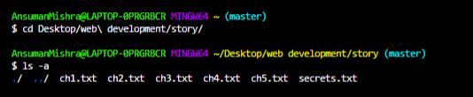

Step 2: Create .gitignore File inside the project folder.

Step 3: Write the name of the files you want to ignore in the .gitignore text file. Each file name should be written in a new line.

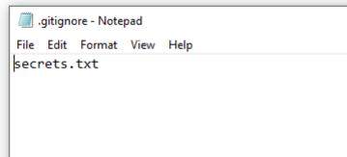

Step 4: Initialize git in your terminal. Add these files to your git repository and commit all the changes with an appropriate message.

git init
git add .
git commit -m "your message"

Step 5: Check the status of the git repository. The file(s) added to the .gitignore text file will be ignored by the git every time you make any changes and commit.

git status

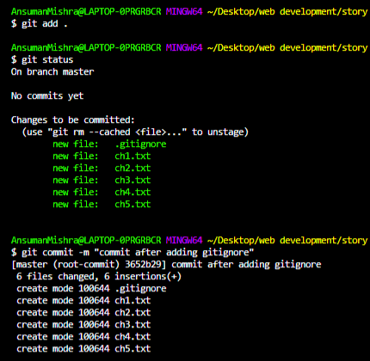

How to Setup Git Server on Ubuntu

Before we begin, make sure we have a clean installation of Ubuntu 20.04 LTS and that you are logged in as a user with Sudo privileges. Now we'll see the initial steps to set up and run Git Server on Ubuntu -

Step 1: Install Git

The first step is to install Git on your Ubuntu server. To do this, open a terminal and enter the following command:

sudo apt-get update

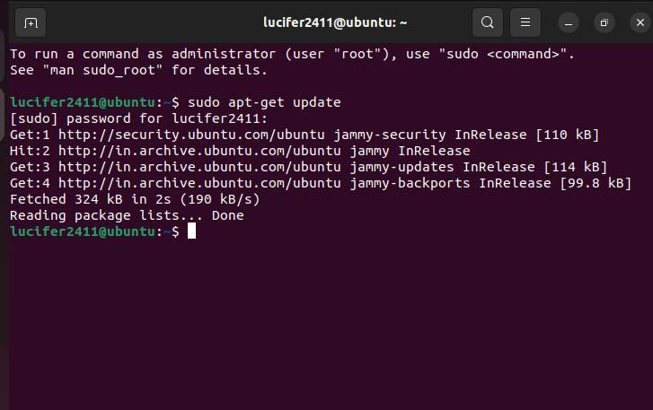

sudo apt-get install git

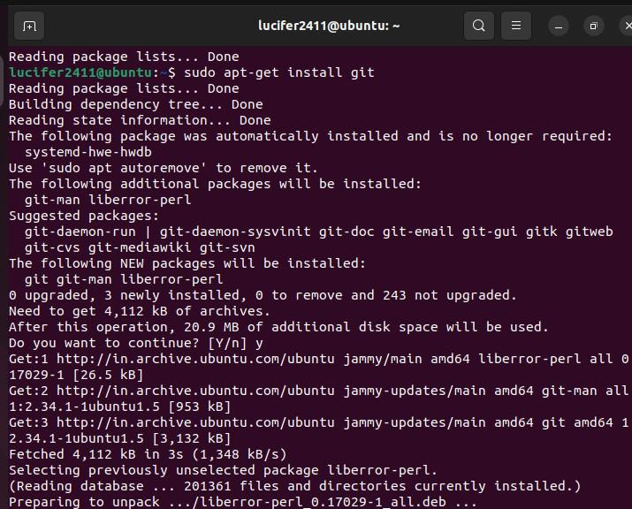

git --version

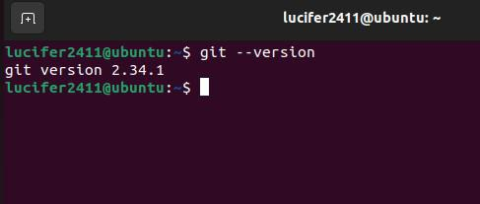

Step 2: Create a Git User

Next, you need to create a new user account that will be used to manage the Git repositories. This is a best practice as it helps to keep the repositories separate from your main user account. To create a new user, enter the following command:

sudo adduser git

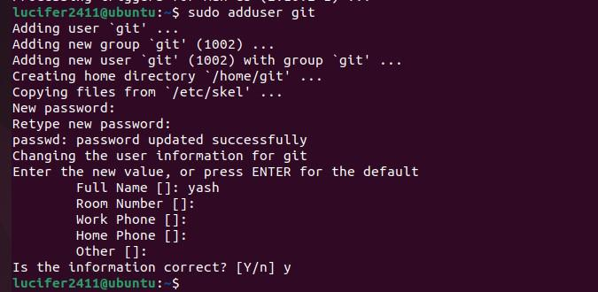

Step 3: Create a Repository Directory.

Next, you'll need to create a new directory on your server where you can store your Git repositories. This is typically done in the /usr/local/ directory. You can create a new directory by running the following command:

sudo mkdir /usr/local/git

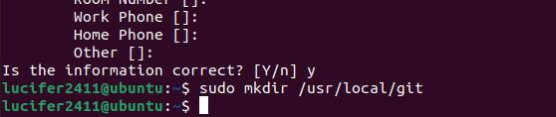

Step 4: Change the ownership of the directory to the git user

Now that you've created the directory for the Git repositories, you'll need to change the ownership of the directory to the GitGit user. This will ensure that the git user has the necessary permissions to read, write, and execute files in the directory. You can change the ownership of the directory by running the following command:

sudo chown git:git /usr/local/git

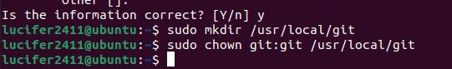

Step 5: Switch to the git user

To complete the setup of the Git server, you'll need to switch to the Gitmy project user account. This can be done by running the following command:

su -l git

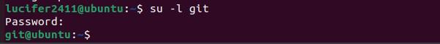

Step 6: Initialize a new bare repository

A bare repository is a type of Git repository that does not contain a working tree (i.e. the files that you're tracking in your repository). Instead, it only contains the Git metadata and history of the repository. This is the type of repository that you'll use for your Git server. To initialize a new bare repository, run the following command in the /usr/local/git directory:

git init --bare myproject.git

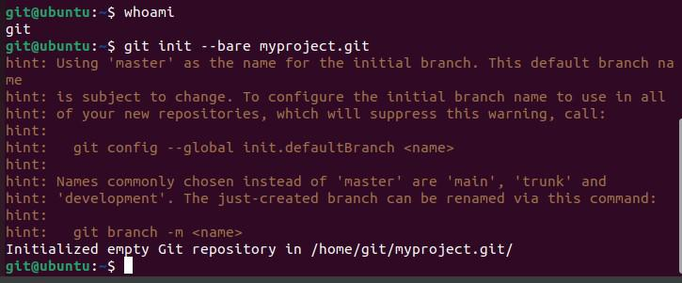

This command will create a new bare repository named "my projectTo.git" in the /usr/local/git directory.

Step 7: Configure SSH access for the git user

ToSSH clone and push to the repository, you need to configure SSH access for the git user. To configure SSH access, you'll need to add the git user's public key to the authorized_keys file in the git user's .ssh directory. You can generate a new ssh key by running ssh-keygen -t rsa -b 4096 on your local machine, type the command:

ssh-keygen -t rsa -b 4096

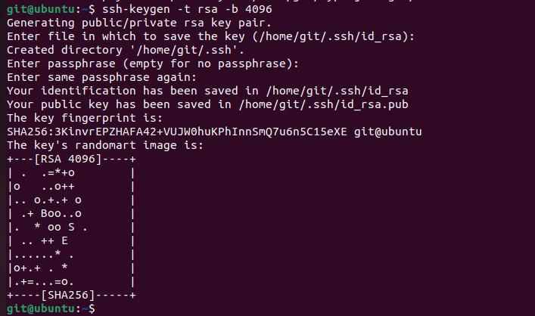

echo "ssh-rsa <your-public-key>" >> ~/.ssh/authorized_keys

Step 8: Allow the git user to connect to the server via SSH

Next, you will need to allow the git user to connect to the server via SSH. You can do this by adding the git user to the SSH AllowUsers list in the /etc/ssh/sshd_config file. Open the file by running sudo nano /etc/ssh/sshd_config and add the following line at the end of the file:

AllowUsers git

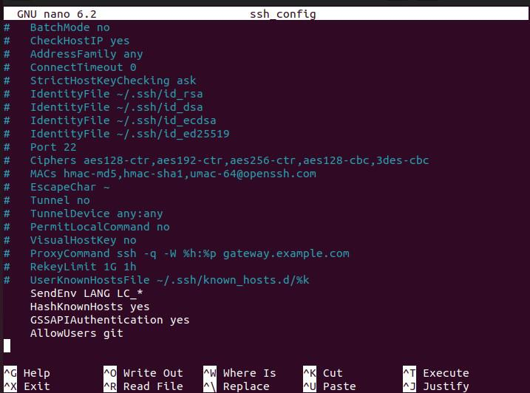

Step 9: Restart the SSH service

After making the changes to the SSH configuration file, you'll need to restart the SSH service for the changes to take effect. You can restart the SSH service by running the following command:

sudo service ssh restart

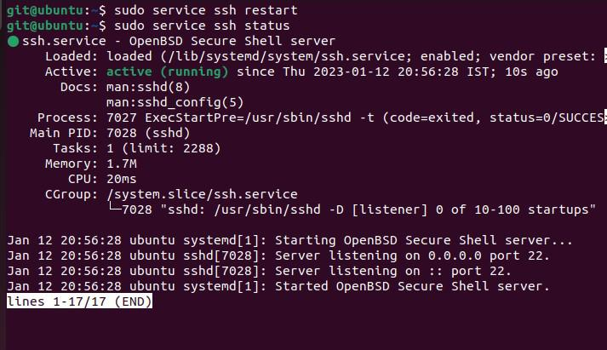

Step 10: Clone the repository from the server

Finally, you can clone the repository from the server by running the following command on your local machine:

git clone git@server:/usr/local/git/myproject.git

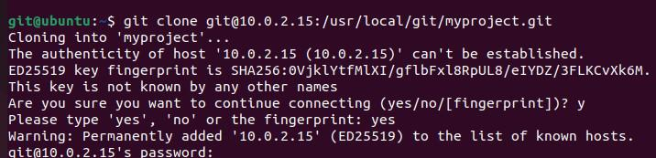

States of a File in Git Working Directory

Git is a powerful version control system that helps developers track changes in their code over time. Understanding the different states a file can be in within the Git working directory is important for effectively managing and organizing your project. This article will explore the various states of a file in Git, explaining what each state means and how it impacts your workflow.

The Git Workflow

Before diving into the states of a file, it's important to understand the basic Git workflow, which consists of three main areas:

Working Directory: The current state of your project files.

Staging Area (Index): A place where you can group changes before committing them.

Repository (HEAD): The history of your project, including all committed changes.

1. Untracked state

Untracked files are any files in the working directory that were not in the last snapshot and are not in the staging area. Whenever a new file is added in the working directory which doesn't exist before, it is considered as an untracked file. This is because Git sees this as a file that didn’t have in the previous snapshot(commit). Let's see this with an example, suppose we add new file example.html in our repository and run git status command to see the status of the file. It shows a list of untracked files which include example.html file.

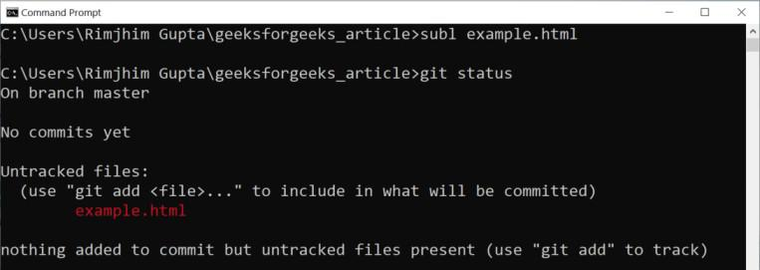

2. Tracked state

Tracked files are files that were in the last snapshot. These are files that Git knows about. Each track file can be in one of three sub-states, modified, staged, or committed.

3. Modified State

A file in the modified state means that changes have been made to it that haven't committed yet. The changes could be adding, modifying, or deleting the contents of the file. These files will be included in the next commit but will be included in their respective new form. Let's modify our tracked example.html file and run the git status command.

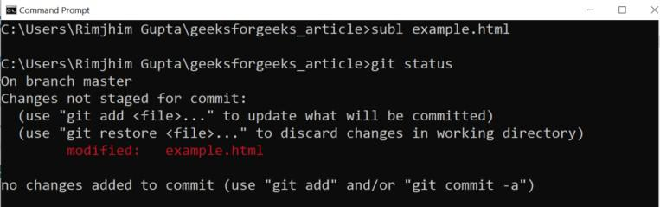

4. Staging State

A file in the staging state means either it is not present in the last commit (e.g. newly created files) or it is “modified” file that user tells git to include in the next commit. Files are added to the staging state using git add command. Two types of files can be added to a staging state: untracked or modified. Let's stage our untracked example.html file and run the git status command.

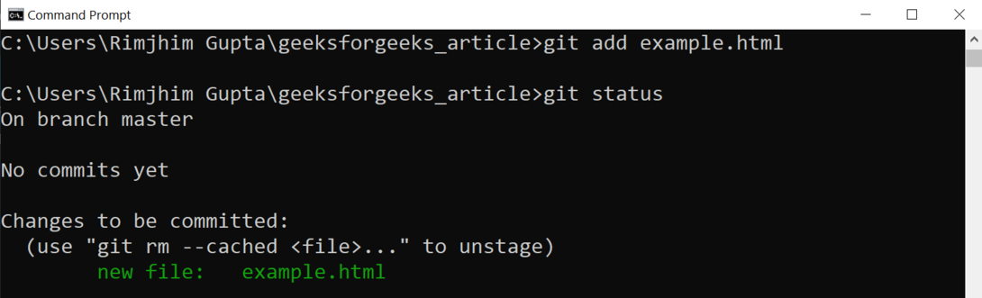

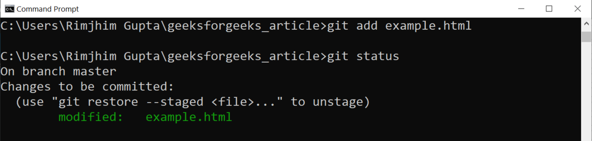

5. Committed State

A file in the committed state means that the changes made to it are safely stored in a snapshot in the Git directory. A file is committed using git commit command.This command creates a new snapshot in the Git directory and shows us some stats for the change made. Let's commit the changes we made in our example.html file.

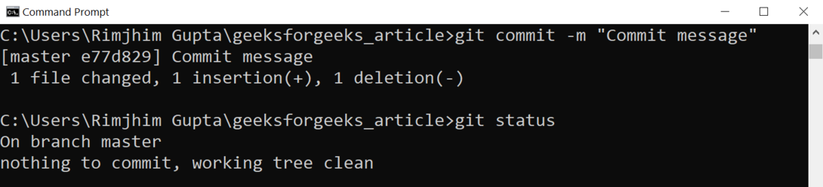

Git - Environment Setup

Setting up your environment for Git is an important step for effective version control in your software development projects. This guide will walk you through the process of installing and configuring Git on various operating systems, ensuring you’re ready to manage your code efficiently.

Step 1. Go to git-scm.com/downloads and download as per your system.



Step 2. If you are using Debian-based GNU/Linux distribution, all you have to do is command sudo apt-get install git-core.

Step 3. Whatever command line you are using, enter “git —version” if it gives back the Git version you are ready to go.

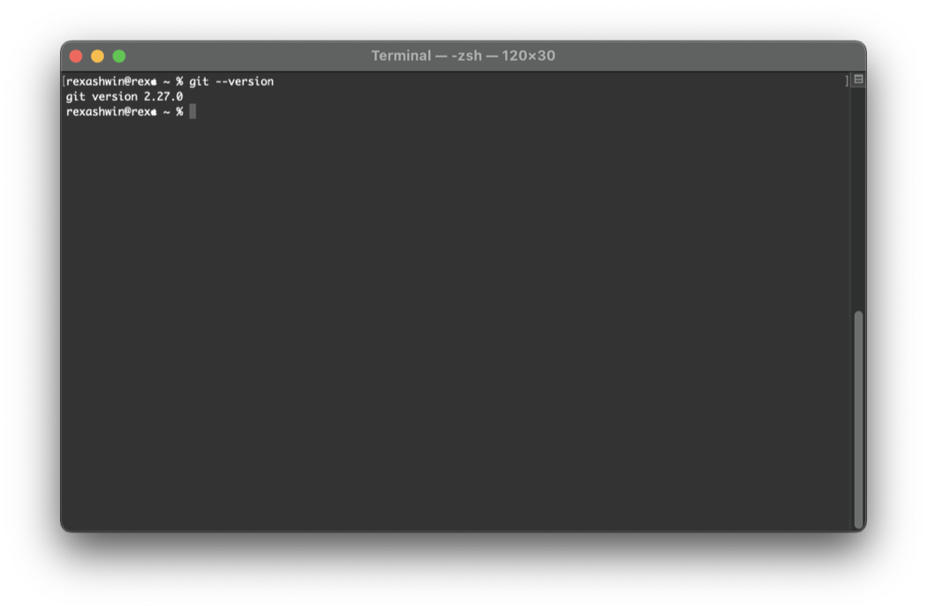
Setting Git Environment

Git has a git config tool, which allows us to set configuration variables. Git stores all the global configurations in a .gitconfig file, which is located in our home directory. To set these configuration values as global, add the --global option, and if you omit the --global option, then our configurations are specific for the current Git repository.

Setting username

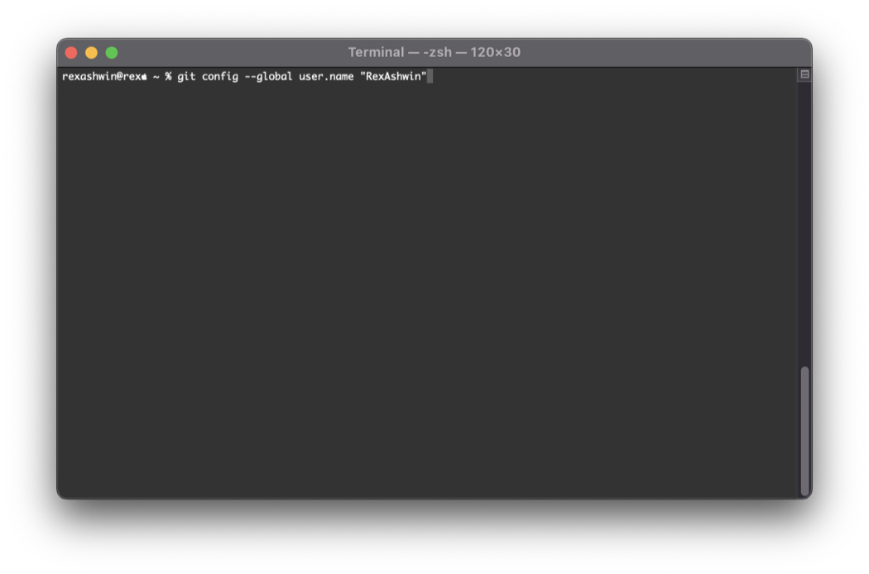
Setting email id

config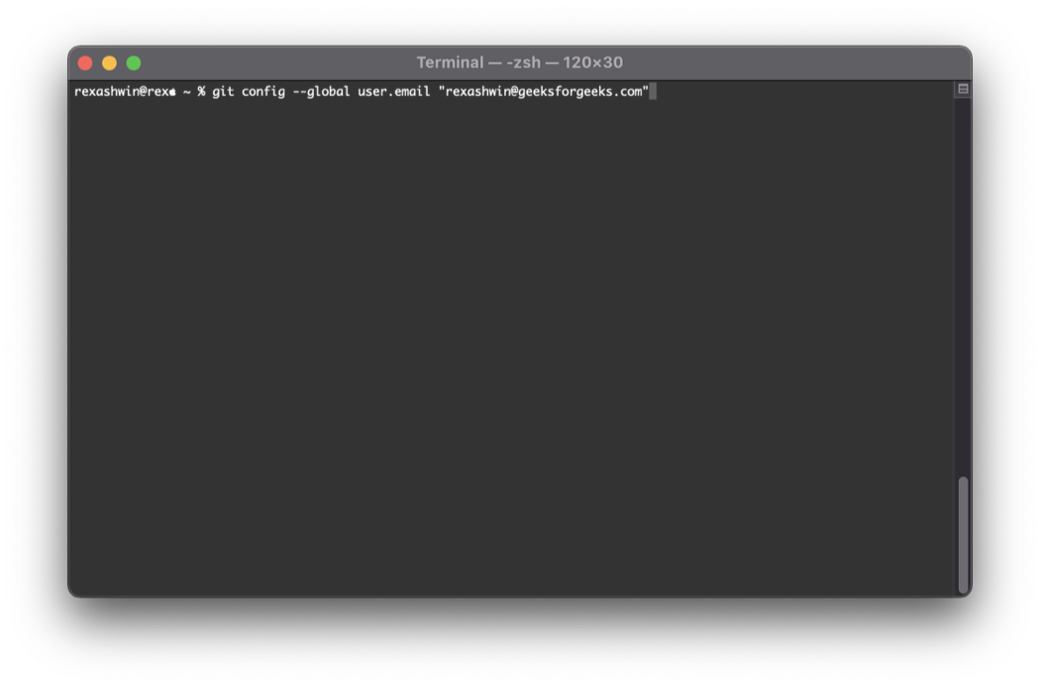

List of Git

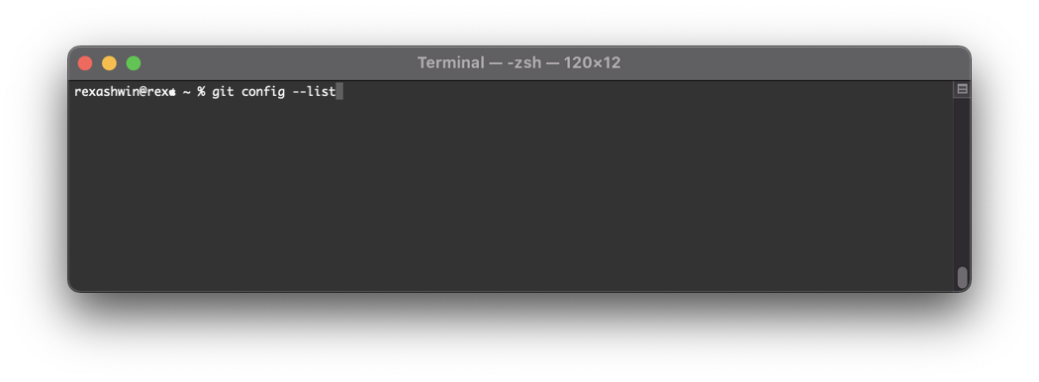

Setting Upstream Branch in Git

An upstream branch is the remote branch your local branch tracks. It acts as a reference for syncing changes, so you can fetch, pull, and push without repeatedly specifying branch names.

Set Upstream Branch using Git Push command

To set Upstream Branch using Git Push, you first have to Create a new branch with the name '' and switch to the current branch using the -b option

git checkout -b <branch name>

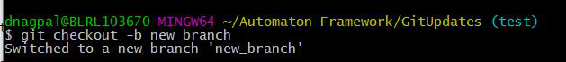

When the current branch i.e ('new_branch') has no Upstream branch set and we try to run the command "Git push". After running the below command in cmd:

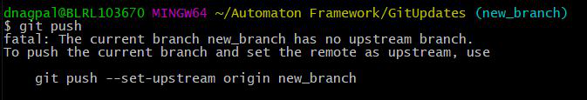

Now, you need to set the upstream branch using the Git push command with the -u option. Replace <branch name> with your branch name.

git push -u origin <branch name>

Alternatively, you can use the '--set-upstream' command as well to set the Upstream branch

git push --set-upstream origin <branch name>

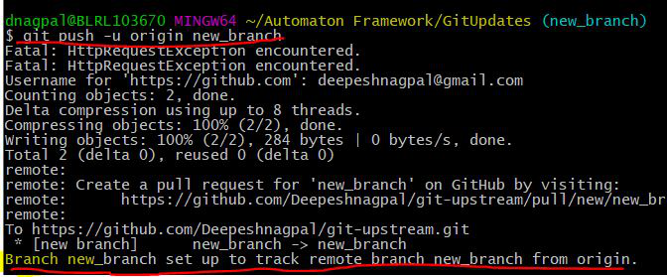

Change Upstream Branches in Git

git branch -u <remote/branch name>

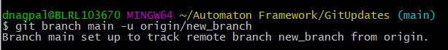

Check Which Branches Are Tracking Upstream Branches

Now To check which Git Branches are tracking which Upstream Branches,you can list all your branches that are tracking upstream branches using "Git branch" with the -vv option:

git branch -vv

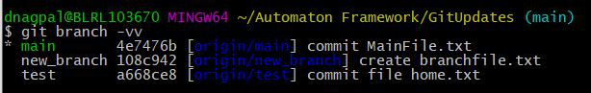

Delete a Git Branch Locally and Remotely

Branches in Git are an essential part of the workflow, allowing developers to work on features, bug fixes, or experiments without disturbing the main codebase. However, once a branch has served its purpose, it’s a good practice to delete it to keep the repository clean and organized.

Delete a Git Branch Locally

Git won't allow you to delete a Git branch you are currently working on. So you must make sure to checkout to a branch that you are NOT deleting. For this use the command:

Syntax

git checkout <branch-name>

Delete the test branch locally:

Syntax

git branch -d <branch-name>

The -d option will delete the branch only if it has already been pushed and merged with the remote branch. If you want to forcefully delete a branch you will have to use the -D option instead. The -D flag is synonymous with --delete --force. This will forcefully delete the branch even if it hasn't been pushed or merged with the remote. the full command is:

Syntax

git branch -D <branch-name>

With this, we can successfully delete a local branch.

Delete a Git Branch Remotely

You can’t use the git branch command to delete a remote branch. Instead, you have to use the git push command with the --delete flag, followed by the name of the branch that you want to delete. You also need to specify the remote name (origin in this case) after "git push". The command is as follows:

Syntax

git push <remote-name> --delete <branch-name>

Here I will delete my test branch in my remote repository as shown below.

This command will delete the branch remotely. You can also use the shorthand:

Syntax

git push <remote-name> :<branch-name>

Patch Operation in Git

Git patch is a feature in git which enables you to create a patch file from a feature in one branch and apply it in another branch. A patch file has all the differences between the two branches. Using the patch file, we can apply the changes in a different branch. This can be visualized as - Suppose you are working on a project. The main project is in the "master" branch. You are working on a feature on a separate branch named "feature1". Now, you make all the changes in the "features1" branch and then create something known as a "patch file". Now, this patch file can be used in the master branch to add that particular feature you worked on.

Creation and Working of Patches

Let's see the following example: Step 1: There is a repository named 'Pat'. The user created a file "text.txt" in the

master.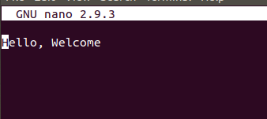

Step 2: Then it is added to the master branch and the change is committed with a message "initial".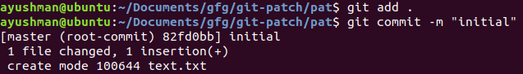
Step 3: Checking logs

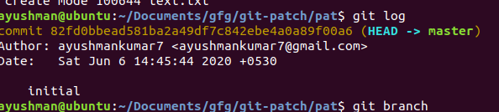

Step 4: Now, let create a new branch named feature and checkout to our feature branch.

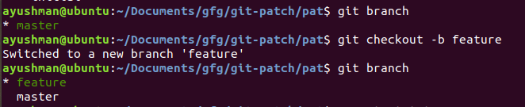

Step 5: Change the "text.txt" by adding a few

words.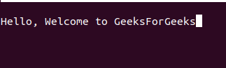

Step 6: Next, we will save these changes, add and commit the changes in our feature branch with a message "this is in feature branch".

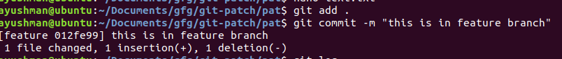

Step 7: Checking logs

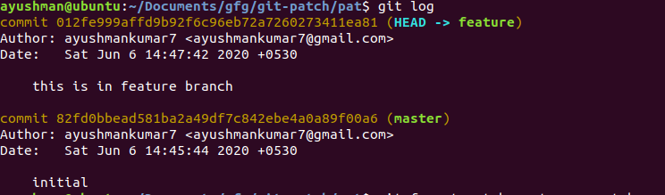

Step 8: Now comes the main part- Creating a patch file. For creating a patch file we will write
git format-patch {branch in which we will apply our patch file} -o {folder in which we will save our patch file}

Currently, we are in the feature branch. We need to compare our changes to the branch where we want to apply our changes(here master branch). Then we use "-o" and specify the folder in which the patch file will be created (this is optional).

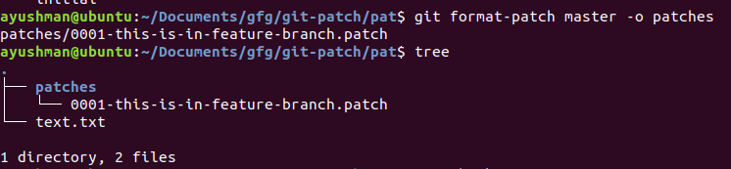
We can also create a patch file using a particular commit's hash key. For example:-

git format-patch -1 012fe999affd9b92f6c96eb72a7260273411ea81 -o patches
The hash key is present in the git log written in dark yellow.

Step 9: Now, we come back to our master branch and check our "text.txt".

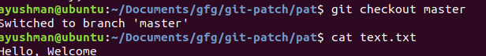

Here, "cat text.txt" is used to view the file. This may not run in Windows. Please use Notepad or any code editor to view this.

Step 10: Now, we finally apply our patch file in the master branch.
git am {path to patch file}

Step 11: Checking logs

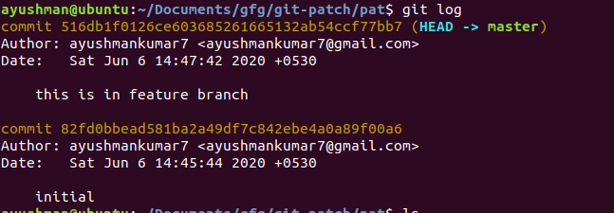

Error Searching and Handling in Git

1. Remove files and folders from the Index: The default functionality of the ‘git add' command is used to add all files and directories to the Index when adding and/or changing files.
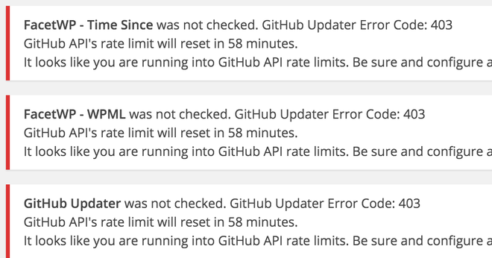

git reset <filename/dirname>

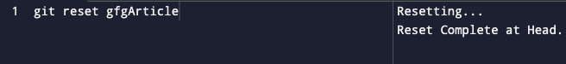

2. Forgot some changes in the last commit: If the user forgot to make some changes and previously committed the snapshot and the user doesn't want to commit again to point out the error.

git commit --amend

3. Edit the most recent message that was committed: It is possible to make changes to the most recent committed message without having to create a new one. Below is the sample command where an alias ‘hist' is created to list the committed logs.

git config --global alias.hist 'log --pretty=format:"%C(yellow)%h%Geeks%ad | %C(green)%s%Geeks%C(blue)%d%for Geeks %C(red)[%an]" --graph --decorate --date=short'x

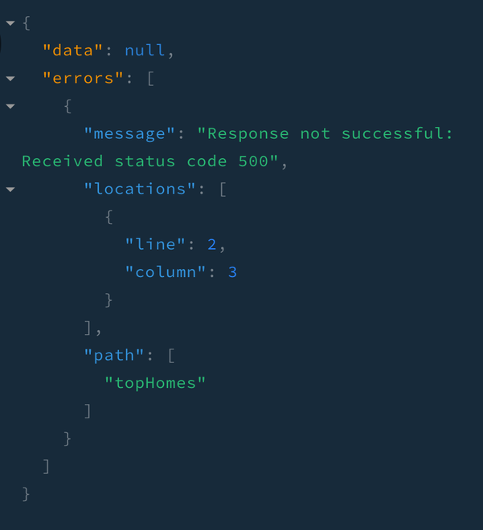

4. Personal data has been committed to a local repository: Sometimes it may happen that the photo saved from the phone's camera goes to the commit folder and gets pushed. Now it is required to delete certain files from the working directory but keep others in the local repository.

git reset --mixed HEAD~
git reset --mixed <commit-id>

5. Changes made locally should be ignored: Let's take an example of an updated and staged 'README' file. Then a second edit is done to the same file. But it was not a required change.

git checkout -- <filename> –local changes in a file

git checkout -- <dirname> –local changes in all the files in the directory

6. Replace the previous commit with a new one: The ‘–soft' option just removes committed files from the local repository while they remain staged in the Index, allowing one to re-commit them after a review. Let's say there is a need to delete the SHA-1 of the snapshot from the local repo is commit-id. <Head -n> where n is the number of commits before the HEAD commit.

git reset --soft HEAD~1

7. Committed the wrong data: Sometimes it happens that the user commits the wrong data to the repository. Let's see how to reset the project to the state before committing the wrong data.

git reset --hard HEAD~n –reset the project to ‘n’ commits before the latest committed snapshot

git reset --hard <commit-id> –reset the project to given commit id snapshot

8. Getting back to the old project state: The fastest and the cleanest way to go back to the old project state is using the reset command in git along with the --hard flag so that everything comes back to its previous state.

git reset --hard <branch-number-here>

- Recovering a Deleted Local Branch: Sometimes, by the virtue of a small mistake, some important local branch might get deleted before it was pushed. In that case, the below command (checking out) will certainly help to recover that lost file.

git checkout -b <branch> <sha-keypair>

10. Fixing the wrong name given to a branch: Sometimes the branch that was just renamed had some typo like Geeks for Geeks became forGeeks, or maybe the user does not like the branch name enough and wants to rename it using a command line. The below command can be used to achieve the same:

git checkout <old_branch_name>

git branch -m <new__branch_name>

11. Re-arranging the history log: It might be really great if some commits are pooled together and then concatenate the commits into one big commit and rearrange them further. To achieve that, git provides an easy way out.

git rebase --interactive <some_random_autogen_id> <your_order_here>

